**Axopar enters the center console market and introduces ‘fishing version’ of the Axopar**   
**29 CCX at Fort Lauderdale International Boat Show**

*Fort Lauderdale, 30 October 2024*

***Axopar continues its 10th anniversary celebrations with the world premiere of the ‘fishing version’ of the Axopar 29 CCX at the Fort Lauderdale International Boat Show. Following the successful debut of the crossover center console model 29 CCX at the Cannes Yachting Festival in September, this version of the boat introduces enhanced fishing capabilities, while retaining Axopar’s signature modularity, multifunctionality, and exhilarating driving experience.***

**A bold new chapter in the Axopar story**

Born from an ambitious vision and a curious mind, the Axopar 29 CCX marks our first venture into the traditional centre console market, with boats that have been made almost entirely with fishing activities in mind. The Axopar 29 CCX breaks that tradition. This model is a true crossover, seamlessly blending utility, comfort, and versatility.

The 29 CCX is our take on how a center console boat can be further enriched by offering the flexibility to handle both fishing trips and social gatherings with its versatile deck layout, while maintaining the same modularity and customer centric solutions that our sports-weekender range is known for. There has never been a center console boat as versatile and adaptable to such a wide range of uses as the Axopar 29 CCX. It is designed to cater to many on-water activities, making it highly multifunctional and user-friendly.

The Axopar 29 CCX now caters to a wide range of boating enthusiasts, from seasoned adventurers to first-time boaters, with complete freedom to choose between going ‘full-on’ fishing or selecting between several of the most sociable layouts out there.

**Jan-Erik Viitala,** Founding Partner of Axopar Boats, says, *“It’s not just about utility and getting from one point to another. It’s about elevating the entire on-water experience by offering a multifunctional, hybrid layout that combines the practical features of a center console walkaround with the exceptional handling and driving pleasure that Axopar is celebrated for. During the Cannes Yaching Festival in September, we launched the ‘sociable’ version of the 29 CCX, and here at Fort Lauderdale International Boat Show, we are excited to showcase the ‘full-on’ fishing version for the first time.”*

**Respecting tradition, redefining the future**

The center console segment is well established and largely dominated by American brands, and for Axopar to enter this segment we have done so with great respect, careful consideration and a sense of humbleness.

We have closely involved our customers in the development of the Axopar 29 CCX, resulting in exceptional adaptability for a variety of activities at sea. Whether for a fishing adventure one day, or a family trip the next, this boat is designed to meet diverse needs and uses.

Our customers wished for greater functionality and flexibility without compromising the drivability and handling that an Axopar is known for. The Axopar 29 CCX is the result of this evolution, combining the sturdiness and utility of a traditional center console, with Axopar’s unique, signature style.

**Designed for the dedicated center console adventurer**

The Axopar 29 CCX is designed with the distinct needs and preferences of center console customers in mind, recognizing the subtle, yet important, differences that set them apart from other types of customers.

* **The console:** The Axopar 29 CCX is designed for increased weather protection, essential for long journeys to favourite fishing grounds or explorations that may require several hours of continuous travel at high cruising speeds exceeding 35 knots. The console features a forward tilting, fully enclosed toughened glass windshield and side windows, offering excellent protection from tiring wind-chill, spray and rain. Negative angle windshields, such as this, help reduce glare, and displace rain and spray very effectively, so that wipers are rarely needed. The forward extending hardtop contributes to the boat’s modern look offering better sun protection and, when needed, airflow for the driver through its integrated skylight located in front of the helm.
* **Enhanced deck features**: A more athletic appearance with the raised bulwarks that also enhance offshore capability and safety while moving around the deck, even during intense fishing sessions. All Axopar 29 models are European CE-rated for category B, (offshore, max 4 m wave height and winds up to 34-40 knots). The integrated handrails help prevent fishing lines from snagging and optional coaming pads offer increased comfort. The proven deck design, with purposeful walkaround side decks without steps and flush floor level for the helm provide better visibility and a safer look out.
* **Additional roof features and options:** The hardtop allows for the addition of a forward facing 10000+ lumens light bar for low light conditions. The CCX can also be specified with downward facing flood lights directed onto the fore and aft decks. Together these lights form the work lights option. The hardtop also includes a foldable 360° anchor light and preparations for telescopic outriggers, one on each side. A 100 W solar panel provides a practical solution for trickle charging the boat’s battery systems when shore power is unavailable. The hardtop can also be equipped with radar, search light, rod holder bar and spray hood to better cover the sides of the helm.
* **Lighting package:** The lighting package includes deck lights, dimmable ambient cockpit lights, dimmable down facing led lights in cockpit and red night vision lighting at the helm.
* **Fish box:** The foredeck features a 19-gallon (74 litres) insulated fish box with a macerator, ensuring your catch stays cool and fresh. The fish box also extends the seating in the fore deck area and can be utilized with the optional hi-lo table and sun pad, thus it is not available together with the starboard side storage module U-sofa.
* **Made for twin engines:** The 29 CCX is mainly optimised for twin engine configurations, offering improved manoeuvrability, safety and redundancy venturing into deep waters. A single engine configuration works perfectly for those seeking a lower initial cost and maintenance with slightly better fuel efficiency.
* **Extended range**: A 158-gallon fuel tank(600 litres) provides up to 300+ nautical miles of range, ensuring more than sufficient capacity for both inshore and offshore adventures. This represents a massive 100 percent increase in both range and capacity compared to the Axopar 28.
* **Elevated looks:** For those seeking an even sportier look, the optional BRABUS Line trim package enhances the athletic appeal of the Axopar 29 CCX, adding a touch of sophistication to its practical design. The 29 CCX comes standard with Linetex upholstery in Chalk, a lighter shade to keep the seating cooler in hot climates.
* **Premium sound system:** Exclusively for the 29 CCX, we are introducing an even more enhanced sound experience with an upgraded JL Audio Premium Sound system, which delivers superior sound quality on the water. Eight 6,5” speakers providing 480 W, powered by a 8 channel 800 W amplifier, two tweeters at the helm and a 10” 250 W subwoofer, guarantee a more powerful music experience.

**Modularity expressed through different aft deck layouts**

Why compromise when you don’t have to? The Axopar 29 CCX is designed to be fully customizable, offering several different aft deck configurations to suit a variety of functional preferences and requirements. This modularity and multifunctionality, which have been at the core of Axopar's success from the beginning, are now available for a center console boat.

CCX customers can choose from multiple different deck configurations, all with the potential for occasional overnighting for two or even up to four people. The familiar foredeck from the Axopar 29 Sun Top and Cabin versions is carried over, seating up to eight people around an optional U-sofa extension and hi-lo table, which can be converted into a sunbed with the help of infill cushions. Additionally, a fish box option is available on the CCX foredeck.

A large multi cabin beneath the deck provides versatile storage space and can be outfitted with a freshwater toilet, sink, and mattresses to create a full-length sleeping area for two.

**Aft deck options**

* **Open aft deck**: The standard aft deck layout offers a row of four separate seats behind the helm seats, offering plenty of open deck space behind the seats for storage and gear.
* **Main bait well with tackle station**: The Axopar 29 CCX ‘fishing version’ offers a full open aft deck layout, providing ample floor space and unrestricted headroom for rod fishing and landing those extra large catches. Instead of the standard aft seat row, you will find a dedicated 33-gallon (125 litres) bait well with clear top hatch and tackle station, complete with a fish-filleting and cutting board, freshwater tap and sink, and ample under-cabinet storage for reels, lines, tools, and other essential gear. The main bait well features an optional raw water wash down pump.
* **Wet bar**: The wet bar layout option is designed for those who love to entertain. It adds a wet bar module behind the aft seat row, while maintaining ample space for fishing and other activities on the aft deck. It includes a top-loading refrigerator, sink with cold water tap, storage cabinet, and cutting board.
* **Aft deck bench**: This configuration adds a rear facing bench behind the standard aft seat row, providing seating for up to three additional people, ideal for transporting larger groups. This option is not available with the wet bar, multi storage / aft cabin, u-sofa and main bait well configurations.
* **Foldable aft leaning post:** At the rear of the deck, next to the transom, a forward facing sofa seating up to three people, featuring a flip-up seat base to create additional standing space when needed. The entire sofa module folds forward on to the deck, which enables tilting the engines out of the water. On top of the leaning post, six additional rod holders are included and when combined with the gunwale holders and the rod holder bar mounted on the hardtop, you can accommodate up to 16 rods. This foldable aft leaning post can be combined with the standard seating, wet bar, live well and aft deck bench configurations.
* **Multi storage / aft cabin option**: The multi storage option provides a generous space for transporting gear and equipment. It features a wide opening top hatch for   
  easy loading, making it convenient to stow not just fishing gear, but also items like wakeboards, dive tanks, water skis, and more. This setup ensures that all your equipment can be easily accessed and safely stored from the aft deck. For additional sleeping accommodations, the aft cabin configuration can be selected, featuring cushions and wall panels that create a cozy sleeping area. A sunbed cushion on top of the cabin roof and four forward facing seats behind a large optional cockpit table enhance comfort and functionality. Access to the aft cabin is located underneath the two middle aft seats.
* **Aft U-sofa**: Together with a large, foldable table, the U-sofa option creates an immersive, sociable, multi seating arrangement around the cockpit. With a movable main backrest offering up to four different seating positions that can be changed and swopped around to utilize the seating and lounging space to the max. The table can be lowered to enable a large sunbed, that spans over the entire U-sofa arrangement.
* **Fenderbox wet bar:** The fenderbox wet bar comes with a top loading refrigerator and a sink with freshwater tap, all of which are covered by wooden bamboo lids, which can also be used as cutting boards. This very convenient option can be combined with all aft deck configurations.
* **Smaller fenderbox live well:** The portside fenderbox houses an 18.5-gallon (70 litres) live well with overboard draining. This option cannot be combined with the fenderbox wet bar.
* **Raw water system:** Also known as a sea chest. The sea chest guarantees an efficient water circulation in the main bait and live wells. Therefore, the wells require the sea chest.

**Integrating sustainable practices into design**

The Axopar 29 hull represents its third evolution since the original Axopar 28 was launched over a decade ago. Hydrodynamic improvements have made it one of the most responsive, fuel efficient, and best handling hulls in its class today and customers can expect fuel efficient economy together with a wide cruising speed range from 22 up to 36 knots, resulting in fuel consumption as low as approx. 2.2 miles/US Gallon (1,7 litres/nautical mile).

Axopar boats are built for maximum efficiency and performance, making them lighter, faster and more sustainable than others. Our boats are constructed with up to 35-40 % less material than many traditional boats in their segments, using even up to 50 % less fuel and harnessing power more efficiently achieving speeds that many competitor boats require more power to reach.

This efficiency is complemented with the extraordinary power and capabilities of Mercury Marine’s newest engines, including their Verado 350-400hp V10 single installation or dual FourStroke 200hp V6 models, ensuring both thrilling acceleration, performance and economy. The boat's modular construction philosophy streamlines production, sharing common parts and components across models, which reduces the environmental impact and enhances cost-effectiveness and efficiency in production.

Modular construction not only enhances production efficiency, but also ensures that the Axopar 29 CCX offers exceptional value within this competitive segment. This approach provides an attractive price point without compromising on the quality or performance that Axopar is known for.

**Standard equipment highlights**

* Fixed aluminum fuel tank (158 gallons/600 litres)
* Raised bulwarks (600 mm)
* Raised helm position and flooring from the 29 ST/XC (100 mm)
* Self bailing deck and cockpit
* Integrated side rails
* Recessed cleats
* CCX toughened windshield w. green tint
* Hard top roof w. skylight
* 2 windshield wiper w. wash function
* Sturdy aluminium frame / roof construction
* Reinforced location on hardtop for outriggers
* 4 gunwale rod holders
* Multicabin under the helm
* Linetex Chalk upholstery
* Telescopic bathing ladder under swim platform
* Heavy duty rub rail in grey
* LED navigation lights and anchor light on hardtop
* Bow and stern eyes
* Anchor box
* L-sofa in bow w. storage
* Integrated bulwark steps
* Flagpole
* Foldable light mast
* Electric signal horn
* 3x electric auto bilge pumps and 2x manual bilge pumps

**More fishability options**

* Main bait well with tackle station right behind helm seats (33 gallons/125 liters)
* Foldable aft leaning post: A wider folding sofa at the aft deck
* Live well with overboard drainage in port fenderbox (18.5 gallons/ 70 liters)
* Fish box incl. macerator (19 gallons/74 liters) with overboard drainage in the bow U-sofa extension
* Top loading refrigerator for food storage
* Standard 4 gunwale rod holders with expansion to 16 according to needed
* Gyroscope preparation
* Trolling motor preparation
* Gunwale side bolsters
* Echo sounder 1000 W, thru-hull, SS175H wide chirp
* Twin chart plotter option
* Solar panel trickle charger system 100 W
* Sea chest for live wells and raw water wash down pump
* Work lights
* Rod holder bar on hardtop

**Technical specifications of the Axopar 29 CCX**

Length overall (excl. engines): 30ft 7in / 9,31m   
Beam Width: 9ft 8in / 3m   
Draft to props: 3ft 6in / 0,9m   
Construction: GRP  
Hull design: Twin stepped 20 degree V "Sharp entry hull"  
Max speed range: up to 50 knots  
Fuel consumption : cruise - 1,7l / nm (1x400hp @ 26 kts)

Fuel capacity: 158 gal / 600 litres   
Weight w. average options (excl. engine): 6173 lbs / 2800 kg  
Outboard engines: 300-400hp   
Persons on board: 6 in cat B / 9 in cat C  
Berths: 2+2* persons  
Classification: B-offshore / C-coastal

**Key Technical features of the Axopar 29 CCX**

* **Completely redesigned hull and hydrodynamics.** 
  + drivability and handling developed to a new standard in sub 30-foot boats
  + new improved driving experience, feeling more like a small Axopar 37 to drive
  + most economic cruising speed range optimized for 22 kts to 32 kts @ flat 1.7l/nm
  + increased fast cruising speed, up to 37 knots @ 2.0l/nm
  + increased range, +300nm with fuel tank capacity now increased to 158 gal.
  + improved stability and seaworthiness to take you anywhere in the world
* **New manufacturing techniques and methods** 
  + stiffer and more rigid construction and revised manufacturing methods
  + reduced weight on all components leading for reduced environmental impact
  + all structural sandwich elements in hull replaced by PET recycled materials
  + increased quality in production, improved component longevity
  + streamlined production, higher quality thru repeated procedures and reducing overall cost and waste, offering more to our customers with reduced price impact, keeping the range leading the competitive pack
* **Smart Design and space utilization**
  + advancing design aspect on aesthetics and looks, instantly recognizable
  + incorporating innovative design concepts and additional features for added functionality
  + optimized interior layout, creative use of space
  + more spacious bow layout, for added on board comfort and socializing
  + maximizing functionality in limited spaces, more storage and easier functioning solutions
  + improved wheelhouse layout, a more comfortable and enjoyable user experience
  + greater use of glass areas for better all-round visibility and light

**Pricing**

**Guide price for standard Axopar 29 CCX:**   
86 450 USD

Price not including:

taxes, shipping & handling, insurance, engine, batteries, handover and launching

**Axopar 29 CCX: Highlights**

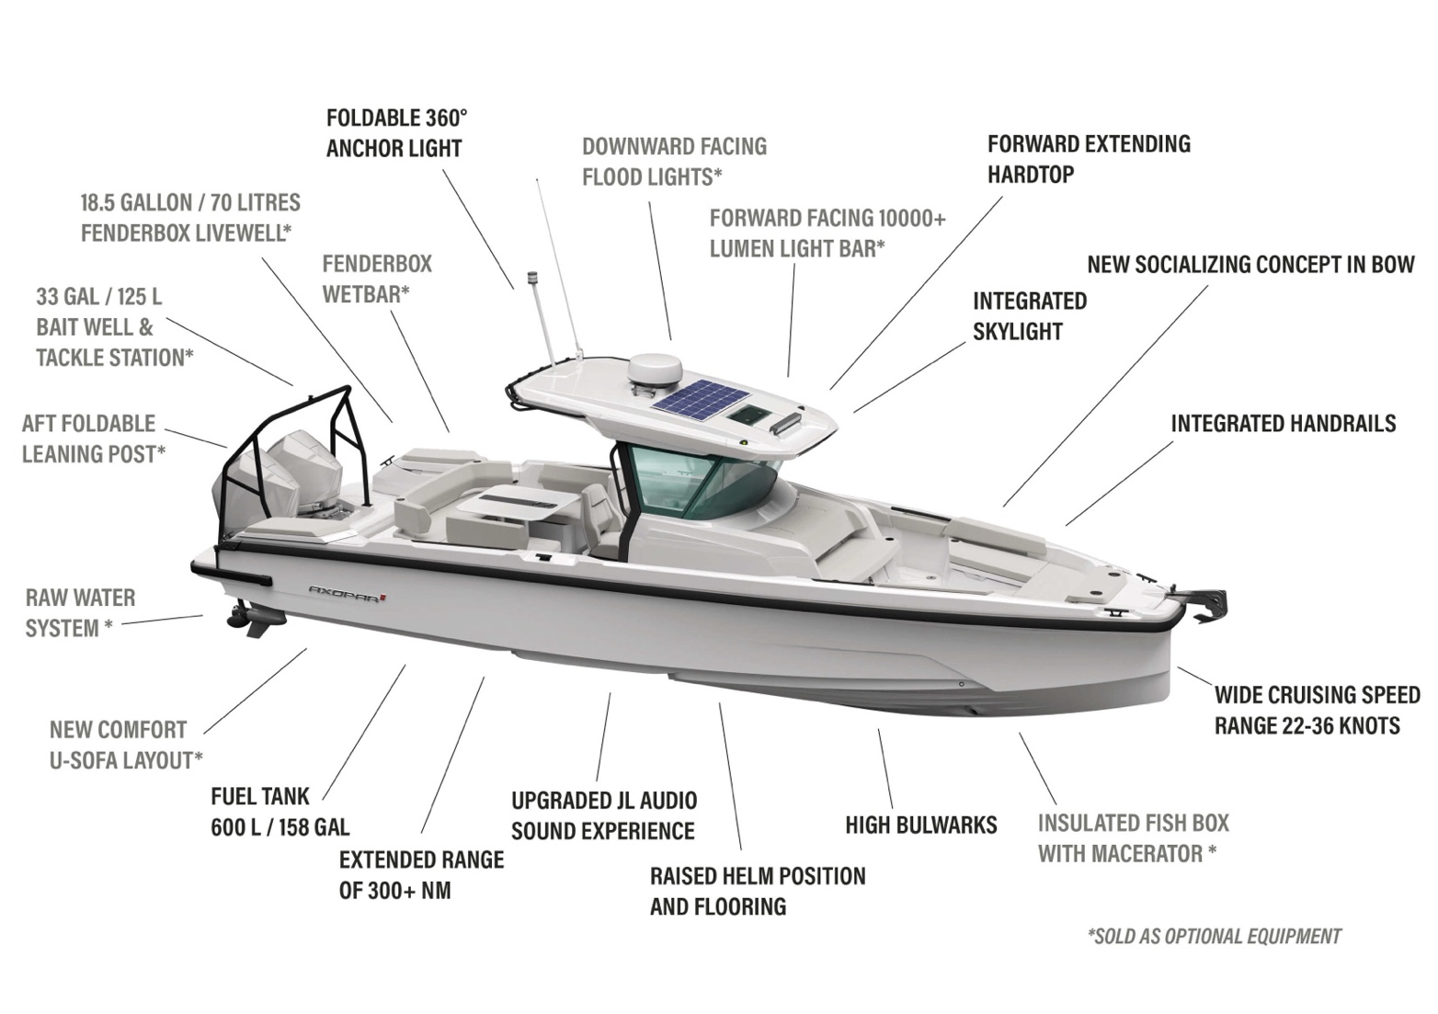

**Media Contacts for More Information on This Release**

Anu Vauhkonen  
Head of Brand & Marketing  
Axopar Boats Oy  
Mobile: +358 40 7652484  
Email: anu.vauhkonen@axopar.com

Press Information:  
Adam Fiander or Mike Wills  
Broad Reach Communications Ltd  
adam@broadreachcomms.co.uk / +44 (0)7703 598903  
mike@broadreachcomms.co.uk / +44 (0)7884 075439

All Axopar releases are available at <https://www.axopar.com/pressroom>