The BRABUS Shadow 1000 Superboat Range Expands with the Latest Phantom Gray Signature Edition
Cannes, September, 2024 — Breathtaking acceleration, high speeds, race-responsive handling and outrageously good looks. Pure excitement and unstoppable power come together to redefine the limits of what is possible for luxury performance boats. The BRABUS Shadow 1000 is one thing above all else: an absolute rulebreaker.
Designed for the bold who are ready to live beyond the limits, the head-turning Phantom Gray Signature Edition is the latest newcomer Signature Edition of the BRABUS Shadow 1000 range. Hitting the waters for the first time as adrenaline-fueled open Sun-Top model and being furthermore available as a fully enclosed XC Cross Cabin model, the latest exclusive BRABUS Shadow truly knows how to take center stage. Inspired by the BRABUS Crawler off-road supercar, this Signature Edition boasts an unmistakable Phantom Gray paint scheme and combines BRABUS typical carbon fiber detailing with exclusive BRABUS Red upholstery colors and outfitting.
Rebellious Meets Powerful
From exhilarating speeds to unparalleled maneuverability, every aspect of the BRABUS Shadow 1000 XC Cross-Cabin and Sun-Top models is engineered to perfection. The superboat range is equipped with twin Mercury V8 500R racing engines, delivering a total of 1,000 horsepower right at your fingertips courtesy of the latest technology available in the industry.

The BRABUS Shadow 1000 offers even more boost, more torque, more responsive steering and higher revs than any other BRABUS Shadow model. Running 4.6-liter V8 powerheads with superchargers, the 500R is the flagship of Mercury Racing’s outboard motor portfolio, featuring an exceptional power-to-weight ratio, ten percent higher torque and a 26 percent increase in supercharger boost pressure. Experience blistering acceleration all the way up to 60 knots, powered by the first-ever marine engine to feature air humidity monitoring to maintain perfect calibration and high performance in any environment.
Harness rebellious power in a clean, functional and uncluttered cockpit that is packed with the best in modern marine technology – ranging from the Intelligent Steering Module that controls the bow thrusters, trim tabs and audio to the innovative Simrad navigational touchscreen displays and optional extended navigation package. The driving experience is further enhanced with Mercury’s JPO (Joystick Piloting for Outboards) joystick steering, including Skyhook and Mercury autopilot features as well as reverse and night vision cameras.
Designed for the Bold
The Phantom Gray Signature Edition look boasts an unmistakable BRABUS 1-Second-Wow effect courtesy of its namesake “Phantom Gray” paintjob. Matching upholstery colors in BRABUS Red as well as a bespoke outfitting package featuring BRABUS Red roof racks, waterski frames and roof pillars set further sporty accents inspired in every detail by the design of the BRABUS Crawler. This exclusive superboat is hand-built with a focus on precision and finish. The process of fairing, painting and polishing alone takes up to six weeks due to non-automated, thorough and highly labor-intensive processes.

Every design element of the BRABUS Shadow 1000 is a testament to the uncompromising fusion of form and function as well as the attention to detail that BRABUS Marine is renowned for. From the unique paint scheme to the luxurious upholstery and branded detailing, this sporty racing machine sets entirely new standards in the world of modern day-boating.

The Sign of Excellence is integrated in the helm area as a seal of exceptional craftsmanship, guaranteeing that every BRABUS Shadow 1000 is a true Masterpiece, built to the highest possible standards with only the best possible materials.
Ultimate Comfort & Innovative Design
Where premium comfort and functionality redefine the superlative. Aboard this Shadow, you will not only experience incredible performance but also unparalleled luxury and social spaces. From the sunbathing area in the bow, the front lounge with gullwing doors, to the helm and cockpit areas with independent sitting spaces and various optional aft deck layouts to choose from, your Shadow will perfectly accommodate any individual needs. Whether you are out with friends to relax or looking for action-packed adventures, the innovative layout and design highlights will guarantee an unforgettable day out at sea.

Customers can choose between several different aft options: an open aft, a wet bar package featuring spacious multi-storage compartments, an overnight aft accommodation package, or the latest highlight of the BRABUS Marine product portfolio: the U-Sofa layout, offering maximum comfort and versatility. Those who opt for the U-Sofa option will benefit from an exquisite dining area, which easily transforms into a large sunbed. Insulated compartments offer additional, more convenient storage and cooling spaces for beverages and snacks.

The BRABUS Shadow 1000 fender boxes feature a new raised design, making them more spacious and enabling the possibility to upgrade with a wet bar including a sink and an electrical fridge on the port side to ensure that any refreshments are only an arm’s length away.

The dedication to luxurious practicality and attention to detail continues inside the front cabin, the optional aft accommodation, and – aboard the enclosed XC Cross Cabin Model – the main cabin house. Customers can choose between distinctive carbon fiber detailing with either a matte or glossy finish, or between two elegant BRABUS Fine Leather options.

Experience a True Rebel

The BRABUS Shadow 1000 Sun-Top and XC Cross Cabin Phantom Gray Signature Editions are full-on rebels, racing across the waves with unparalleled performance characteristics while impressing with a perfectly complemented Signature design, luxurious upholstery and carbon elements as well as painstakingly crafted detail work.

This Masterpiece of adrenaline and agility will be showcased at Cannes Yachting Festival from 10 to 15 September 2024 and Monaco Yacht Show from 25 to 28 September 2024.

EQUIPMENT HIGHLIGHTS BRABUS SHADOW 1000 RANGE
Sun-Top & XC Cross Cabin Phantom Gray Signature Edition

POWER
- Dual Mercury Racing 500R 4.6l V8 supercharged outboard engines

HULL DESIGN
- Exclusive Phantom Gray Signature Edition paintwork with high labor-intensive fairing, painting and polishing

AFT LAYOUT OPTIONS
- Open Aft Deck
- Aft Bench (XC)
- Wet Bar Package
- Multi Storage Compartment
- Aft Cabin Accommodation Package
- U-Sofa

BOW LAYOUT OPTIONS
- Sun Lounge option: extended sunbathing area and storage compartment
- Sofa with table in bow option

UPHOLSTERY COLOURS
- For the Signature Look: Exclusive BRABUS quilted upholstery in BRABUS Graphite or BRABUS Red. Additionally, the upholstery colors BRABUS Sunrise, BRABUS Merlot, BRABUS Platinum and BRABUS Ice are available as further options.
- Main Cabin (XC), Front Lounge and optional Aft-Cabin in BRABUS Fine Leather light gray upholstery or BRABUS Fine Leather dual tone black/light gray upholstery option.

GENERAL EQUIPMENT HIGHLIGHTS
- Joystick Piloting
- Gullwing doors
- Exclusive BRABUS carbon in matte black or in glossy black finish
- Dashboard panels in glossy black carbon
- ⁠Electric opening/closing of sliding sun-roof awning
- Integrated electric toilet under foldable L-Sofa
- Fresh water system 80l including cabinet with sink in front lounge
- BRABUS composite decking in platinum/black
- Shower on aft deck, port side
- Water ski pole in matte black paint
- Side rails
- Full Planofil cover in black
- Sunshades for aft and bow with carbon fiber poles

TECHNICAL EQUIPMENT HIGHLIGHTS
- Glass bridge/information display with two 12-inch screens
- Digital BRABUS watch dial integrated into SIMRAD user interface
- Intelligent steering module with integrated controls
- 1st mate marine safety & security System
- Hi-Fi audio entertainment system with JL Audio
- Bow thruster side -power SE60
- Fixed bow anchor windlass with remote control
- Shore-power 230V or 120V incl. isolator, 60Ah charger
- Wireless phone charger

EXTENDED EQUIPMENT HIGHLIGHTS
- Extended carbon fiber package: BRABUS sports seats with full carbon backrests, exclusively in matte black or glossy black finish
- Red outfitting parts package (red roof racks¹, waterski frame, roof pillars)
- Carbon fiber LED roof light bar in matte black or in glossy black finish
- Extended navigation package: extended glass bridge/ information display with two additional 9” screens, on-board connectivity and 4G/USB mobile Wi-Fi router, VHF unit with AIS receiver and Simrad Halo20+ radar (XC/ST), 5” touch display in front lounge, BRABUS Lock Box including PIN control via touch screen
- Hi-Fi onboard audio system with JL Audio. Premium Upgrade package, incl. 8 x 7.7-inch M6 speakers with sport grill, 2 x 6.5-inch C1 speakers, 1 x subwoofer, and 2 x DSP amplifiers enabling premium sound. The Sun-Top version features 2 integrated tweeters for the helm area.
- Lounge Package
- Enclosed toilet compartment
- Folding aft deck seats²
- Warm water option³
- Air-conditioning in front lounge⁴
- Air-condition in main cabin⁴
- Heater Webasto⁴
- Zero emission power bank
- Gas cooktop on wet bar
- Infotainment media wall
- Roof racks
- Fishing targa

¹ Roof racks to be selected separately
² Not available with BRABUS Aft-Cabin or Multi Storage compartment
³ Warm water option not available with air-condition in both front lounge and main cabin
⁴ Webasto heater and AC are not available at the same time

DETAILING HIGHLIGHTS
- Highly exclusive Phantom Gray BRABUS Masterpiece badges
- Exclusive Phantom Gray Sign of Excellence badges
- BRABUS “Double-B” designations and detailing
- BRABUS Shadow 1000 badging and logotypes
- Sleek hull badges in black chrome
- Wall pockets in BRABUS design - only in combination with optional Aft-Cabin

TECHNICAL SPECIFICATIONS*

Overall Length (excl. Engine): 38ft / 11,6 m
Beam: 3,35 m / 11ft
Draft to props: 0,85 m / 2ft 9in
Weight (including engines) 5400 kg / 11905 lbs. (XC) 5123 kg / 11294 lbs. (ST)
Passengers: 10 Cat B / 12 Cat C
Berths: 2 persons (with optional aft-cabin accommodation package 2+2)
Fuel capacity: 730l / 192gal
Construction: GRP
Classification: B – Offshore, C – Coastal
Top speed: up to 65 knots
Power: 1000 hp
Outboard engine: 2*500 hp
Hull design: Twin stepped 20-degree V “Sharp entry hull”

*Specifications may be changed without prior notice. Performance may vary due to equipment, weather, and load conditions.

FACT SHEET NEW HIGHLIGHTS

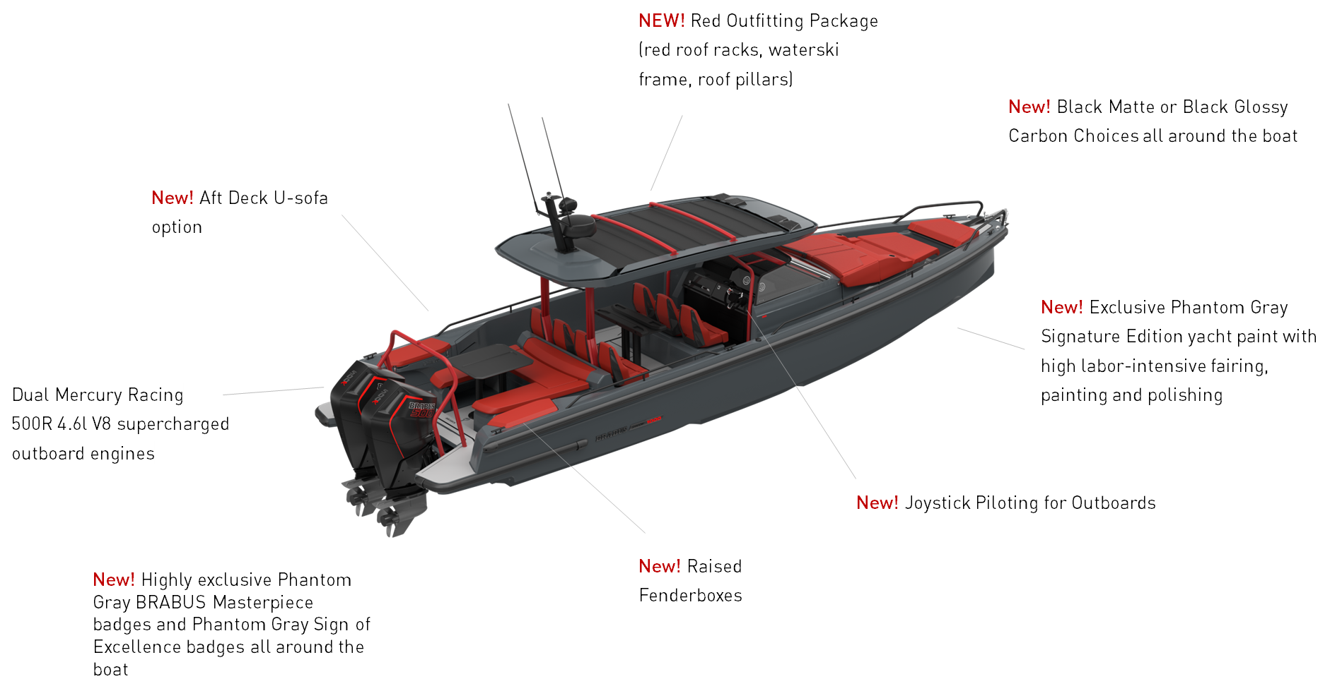

For press inquiries or to schedule interviews, please contact:
Anu Vauhkonen
Head of Brand & Marketing
Axopar Boats Oy
Mobile: +358 (0)40 765 2484
Email: anu.vauhkonen@axopar.com

Press Information:
Adam Fiander or Mike Wills
Broad Reach Communications Ltd
adam@broadreachcomms.co.uk / +44 (0)7703 598903
mike@broadreachcomms.co.uk / +44 (0)7884 075439

About BRABUS Marine
BRABUS Marine is the cutting-edge alliance between two of the most renowned companies in their respective genres. Bringing together the award-winning Finnish boat builder Axopar Boats and BRABUS, a world-renowned luxury mobility brand out of the heart of Germany’s Ruhr-Region, to redefine luxury day boating through ultra-exclusive and exciting powerboats. BRABUS Marine specializes in luxury products for global markets and is driven to become one of the world’s most iconic boat brands.
http://www.brabusmarine.com/

