The new BRABUS Shadow 45 Range: Masterpiece Luxury Meets Next-Level Performance at 45 Feet
BRABUS Marine introduces a new era of customizable performance superboats at Cannes Yachting Festival 2025 with the refined Shadow 1200 and the Shadow 1500.

CANNES, 09.09.2025 — The BRABUS Shadow 45 range represents the new pinnacle of performance and luxury on the water. For the first time, BRABUS Marine offers customers the choice between two distinct character profiles built on the same 45-foot platform: the confidently refined BRABUS Shadow 1200 and the new BRABUS Shadow 1500.

The Shadow 1200 embodies the spirit of a true Gran Turismo of the seas — designed for those who value effortless long-distance cruising and unmistakable BRABUS styling. Meanwhile, the Shadow 1500 is a bold, confident performance Masterpiece, the right choice for customers who seek the thrill of pure, race-inspired power fused with the highest level of bespoke craftsmanship and onboard luxury.

Together, they set the stage for a new era of the BRABUS Shadow range, offering two unique superboats inspired by the same uncompromising luxury, technical functionality and style-forward design that has become synonymous with the BRABUS name.

THE NEW BRABUS SHADOW 1500
At the heart of the new Shadow 1500 are three supercharged Mercury Racing V8 engines, producing a combined output of 1,115 kw / 1,500 hp. This powertrain makes the Shadow 1500 one of the most agile high-performance dayboats in its class — boasting uncompromising acceleration and handling precision that transforms every voyage into a thrilling, visceral adventure. Exclusive features, including a premium audio system and an extended navigation package, further enhance the onboard experience. Brand-typical design elements set unmistakable accents across both the signature-style exterior and the extravagant, customizable Masterpiece interior.

The helm setup is deliberately configured without Joystick Piloting for Outboards (JPO) as standard, ensuring the most direct connection between driver and machine at high speeds. For clients prioritizing docking assistance and advanced positioning control, JPO is offered as an optional system upgrade.

The prototype presented at the Cannes Yachting Festival showcases the German luxury mobility brand’s unique approach to modern design and maximum individuality with a fully monochromatic design concept in “Stealth Green,” featuring matching outfitting and upholstery, inspired in every detail by the world of bespoke BRABUS supercars.

REFINING THE BRABUS SHADOW 1200
Alongside the debut of the Shadow 1500, the Shadow 1200 enters the 2026 season with a new propulsion setup featuring three Mercury Verado 400 V10 outboard engines. Delivering a balance of performance, efficiency and refinement, this configuration enables effortless cruising at 40 knots and a top speed of up to 55 knots.
With improved acceleration, optimized propeller geometry and a redesigned gear case, the Shadow 1200 now offers an even smoother, more efficient ride, perfectly embodying the Gran Turismo philosophy of the seas.

EXCLUSIVE. FULLY CUSTOMIZABLE. TAILORED TO YOU.
The Shadow 45 Range is available in three distinctive models, each designed to suit different lifestyles and preferences: the versatile XC Cross Cabin, the open and airy Sun Top and the markedly sporty Cross Top. Select your model, choose your unique signature style, then match it with either the triple Mercury Verado 400 V10 outboard engine setup for the Shadow 1200 or triple supercharged 500hp Mercury Racing V8 engines for the Shadow 1500. The result is a fully customized performance boat, tailored precisely to the style and ambitions of its owner.

THE NEXT CHAPTER IN LUXURY PERFORMANCE BOATING
With the refinement of the Shadow 1200 and the worldwide debut of the Shadow 1500—the most powerful and individually customizable BRABUS Shadow to date—BRABUS Marine once again sets a new benchmark in the world of performance luxury on the water. Engineered for extremes, designed for individuality and unmistakably BRABUS Marine, the new and improved Shadow 45 range represents the future of high-performance boating.

The BRABUS Shadow 1500 will be unveiled with a showcase of the BRABUS Shadow 1500 Cross Top Stealth Green Signature Edition during an exclusive press event on the opening day of The Cannes Yachting Festival 2025, 9-14 September 2025.

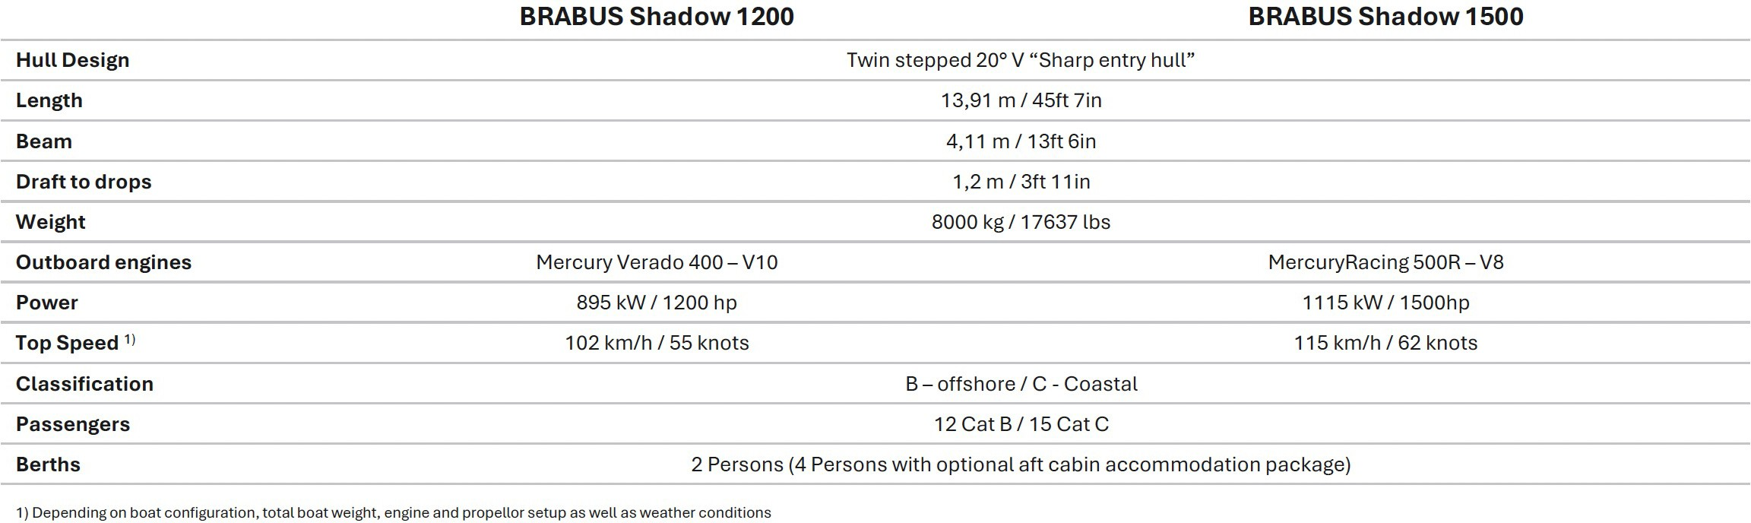
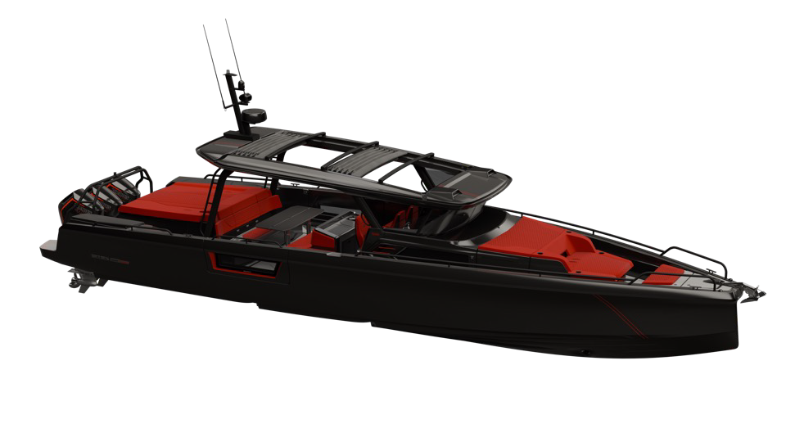
BRABUS SHADOW 45 RANGE SPECIFICATIONS

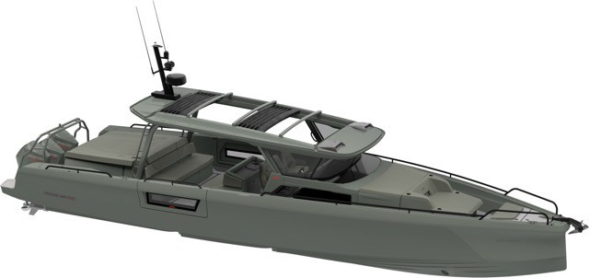

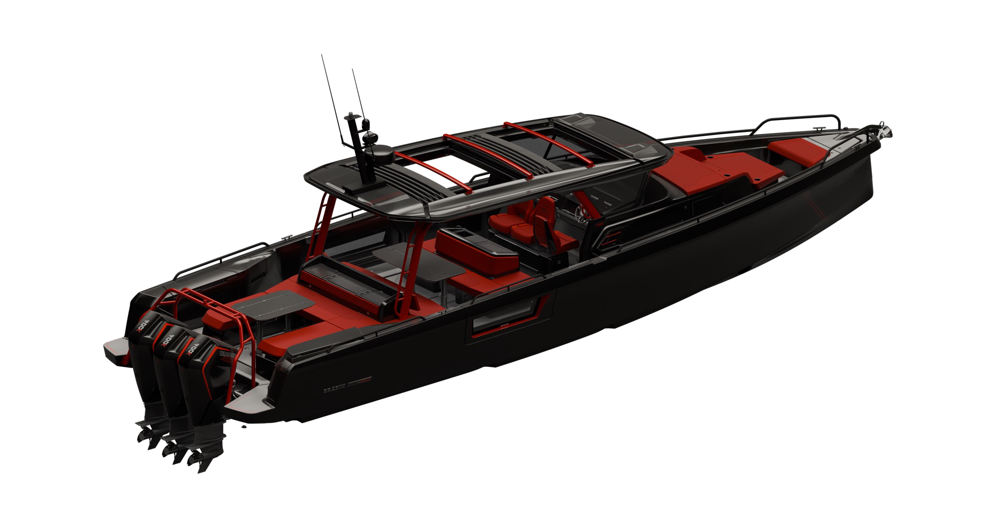
BRABUS SHADOW 45 RANGE HIGHLIGHTS

Matte or glossy carbon fibre choices all around the boat

Modular aft deck layout with options for u-sofa, aft cabin, or aft deck bench

Triple Mercury Verado 400 V10 outboard engines
or

Triple Mercury Racing 500R 4.6l V8 supercharged outboard engines

BRABUS composite decking in platinum/black finish
Red Outfitting Package (red roof racks, waterski frame, roof pillars)

Signature gullwing doors to enter the front cabin

Dual-tone BRABUS fine leather interior in front cabin and in optional aft cabin

Highly exclusive BRABUS Masterpiece badges and Sign of Excellence badges all around the boat

Exclusive BRABUS quilted upholstery in BRABUS Graphite, BRABUS Red, BRABUS
Sunrise, BRABUS Merlot, BRABUS Platinum or BRABUS Ice

Signature Edition yacht paint with high labor-intensive fairing, painting and polishing in
- Black Ops
- Stealth Green
- Phantom Gray
- Deep Blue

BRABUS Shadow 1200 or 1500 hull logo

Multifunctional steering wheel with BRABUS Logo

Joystick piloting for outboards (JPO)
Illuminated side balcony doors with windows

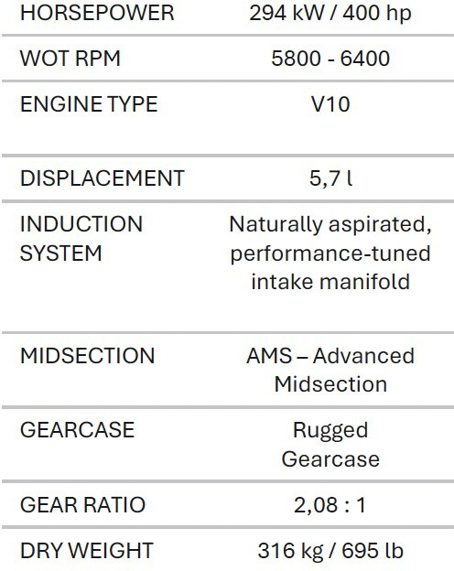
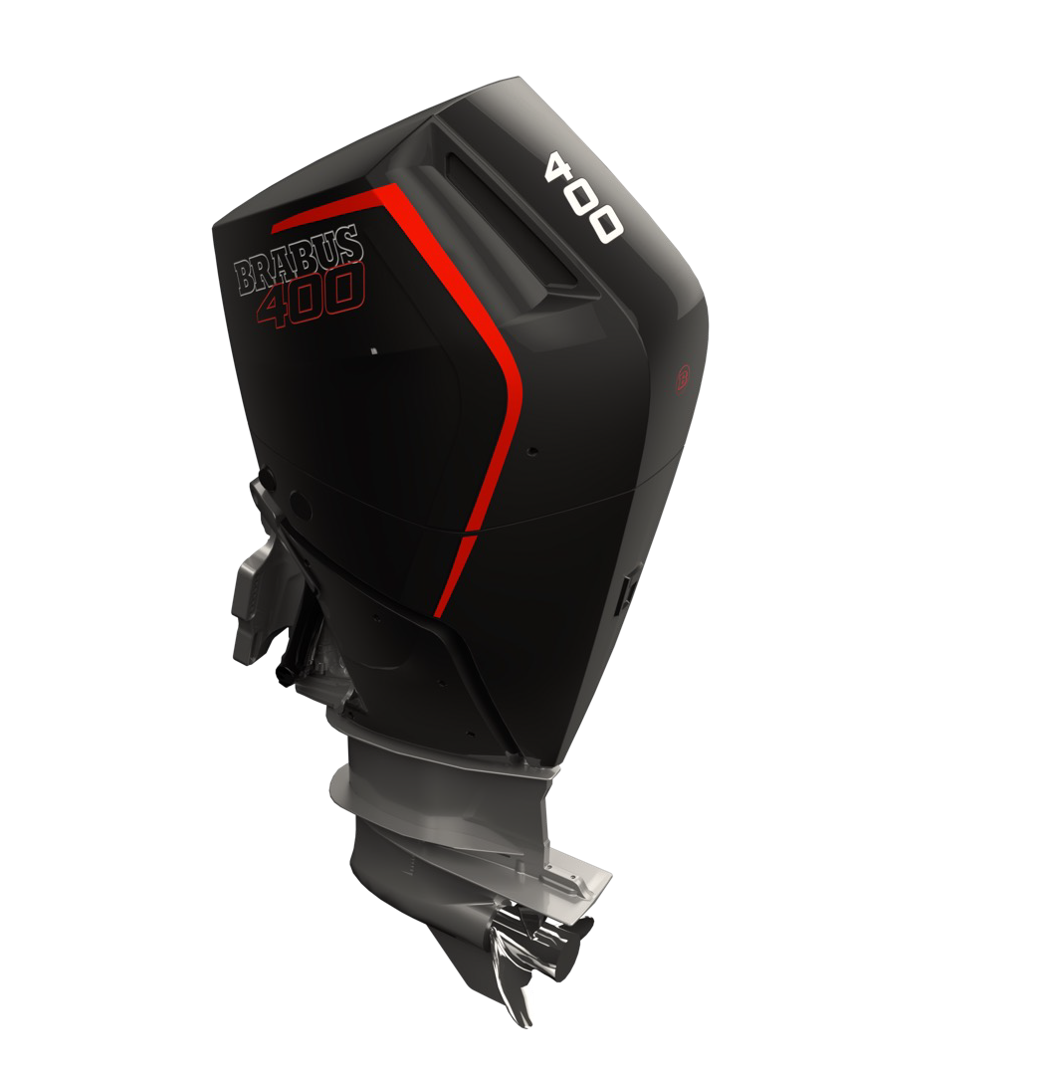
BRABUS SHADOW 45 RANGE ENGINE OPTIONS

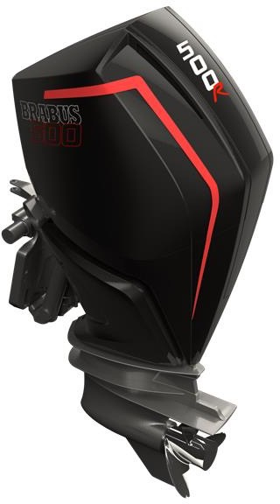

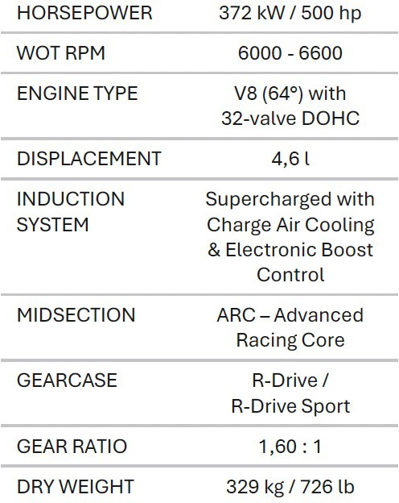

BRABUS SHADOW 45 RANGE EQUIPEMENT DETAILS
available as EU version with 230 V electrical systems and US version with 110 V electrical systems

POWER
  - Shadow 1500: Triple Mercury Racing 500R 4.6l V8 supercharged outboard engines with a combined power output of 1,500 hp (1,115 kW) with painted engine covers and BRABUS engines decals
  - Shadow 1200: Triple Mercury Verado 400 5.7l V10 outboard engines with a combined power output of 1,200 hp (885 kW) with painted engine covers and BRABUS engines decals

MODELS
  - XC Cross Cabin Signature Edition
  - Cross Top Signature Edition
  - Sun Top Signature Edition

HULL DESIGN
  - Exclusive Stealth Green Signature Edition yacht paint in BRABUS Stealth Green
  - Exclusive Black Ops Signature Edition yacht paint in BRABUS Graphite Black
  - Exclusive Stealth Deep Blue Edition yacht paint in BRABUS Deep Blue
  - Exclusive Stealth Phantom Grey Edition yacht paint in BRABUS Phantom Grey

AFT LAYOUT OPTIONS
  - Open Aft Deck (XC Cross Cabin only)
  - Aft Deck Bench
  - U-Sofa
  - Aft Cabin

UPHOLSTERY COLORS
  - Exclusive BRABUS quilted upholstery in BRABUS Graphite, BRABUS Sunrise, BRABUS Red, BRABUS Merlot, BRABUS Platinum or BRABUS Ice
  - Front lounge and optional aft-cabin in exclusive BRABUS Masterpiece leather in light grey/black color scheme with red accents or BRABUS Masterpiece leather light grey color scheme, and mattress in gray/black square pattern

GENERAL EQUIPMENT HIGHLIGHTS

MAIN / FRONT CABIN
  - Ingress / egress through Gullwing doors or directly from helm
  - Cooler in front lounge
  - Floor carpets in BRABUS Black
  - Exclusive BRABUS carbon interior accent parts
  - Integrated bathroom with shower, sink and toilet
  - Bathroom in the front lounge with shower, sink and toilet
  - Infotainment media wall

WHEELHOUSE / MAIN DECK
  - BRABUS front seats with full carbon backrests, in matte or glossy finish
  - Exclusive BRABUS carbon interior accent parts
  - Exclusive BRABUS carbon dashboard
  - Dual electric sunroofs
  - Carbon fiber color selection in either glossy or matte finish
  - Balcony doors with windows
  - Wet bar with sink, fridge and (optional) induction cooktop
  - Adjustable table between aft bench and wet bar
  - Exclusive BRABUS carbon interior accent parts
  - Exclusive BRABUS carbon dashboard

EXTERIOR / AFT DECK
  - Exclusive BRABUS carbon exterior styling parts
  - BRABUS composite decking in platinum/black finish
  - Shower on aft deck, port side
  - Water ski pole, matte black paint
  - Sunshades for front and aft deck with carbon fiber poles
  - Harbor covers
  - Full planofil cover in black
  - BRABUS mooring package

TECHNICAL EQUIPMENT HIGHLIGHTS
  - Intelligent Steering Module (ISM) BRABUS steering wheel in leather with integrated controls for audio, trim tabs and bow thruster
  - Twin Simrad NSO 16-inch Multifunction displays with BRABUS user interface
  - Additional Simrad 9-inch additional helm display
  - Optional Extended BRABUS Navigation package:
    - Extended glass bridge/ information display with two additional 7-inch screens
    - On-board connectivity and 4G Wi-Fi router
    - VHF unit with AIS receiver and Simrad Halo20+ radar
    - 5-inch touch display in front lounge
    - BRABUS lock box and additional BRABUS roof instruments
  - Reverse/aft deck camera
  - Dimmable LED interior lights
  - Deck and underwater lights
  - LED search light with remote control functionality
  - Echo sounder, thru hull
  - Battery monitoring system
  - BRABUS premium audio system by JL Audio: Hi-fi audio entertainment with remote control functionality
  - Side-Power bow thruster
  - Fixed bow anchor windlass with remote control functionality
  - Dual shore-power 230V or 120V
  - Multiple USB sockets for charging in helm and front lounge
  - Fresh water system

EXTENDED EQUIPMENT HIGHLIGHTS
  - Carbon fiber LED roof lights in matte or glossy black finish
  - Full RGB lighting for interior, deck and underwater lights
  - Additional drawer fridge STBD
  - Additional drawer fridge PORT
  - Additional 65-liter fridge for wet bar
  - Electric grill on wet bar
  - Induction cooktop on wet bar
  - Wet bar in fender box
  - Barbecue grill for fender box wet bar
  - Front night vision camera
  - Toilet in aft cabin
  - Infotainment media wall for aft cabin
  - Warm water system with 30l boiler
  - Air-conditioning in front lounge* with outlets in optional aft cabin*
  - Webasto heater*
  - 1000Ah power bank incl. 6kVA inverter system
  - Solar panel
  - Roof racks
  - Aft gates
  - Fishing targa
  - Antifouling, black or gray
  - Rub rail, black
  - Echo sounder, Active Imaging 3-in-1
  - Optional Stabilizer system: Quick Gyroscope MC2 X10 DC

* Webasto heater and AC are not available at the same time

DETAILING HIGHLIGHTS
  - Painted engine covers matching the hull color
  - Exclusive BRABUS Masterpiece badges in BRABUS Hull and Paint color
  - Exclusive Sign of Excellence badges in BRABUS Hull and Paint color
  - BRABUS “Double-B” designations and detailing
  - BRABUS Shadow 1200 or 1500 badging and logotypes
  - Sleek hull badges in black chrome

STARTING PRICE:
BRABUS Shadow 1200 Sun Top 1 060 000 €
BRABUS Shadow 1200 Cross Top 1 090 000 €
BRABUS Shadow 1200 Cross Cabin 1 120 000 €

BRABUS Shadow 1500 Sun Top 1 165 000 €
BRABUS Shadow 1500 Cross Top 1 195 000 €
BRABUS Shadow 1500 Cross Cabin 1 225 000 €

Media contacts for more information on this release:
Ms. Anu Vauhkonen
Head of Brand & Marketing Axopar Boats Oy
Mobile: +358 (0)40 765 2484
Email: anu.vauhkonen@axopar.com

Press Information:
Adam Fiander or Mike Wills Broad Reach Communications Ltd
adam@broadreachcomms.co.uk / +44 (0)7703 598903
mike@broadreachcomms.co.uk / +44 (0)7884 075439

About BRABUS Marine

BRABUS Marine is the cutting-edge alliance between two of the most renowned companies in their respective genres. Bringing together the award-winning Finnish boat builder Axopar Boats and BRABUS, a world-renowned luxury mobility brand out of the heart of Germany’s Ruhr-Region, to redefine luxury day boating through ultra-exclusive and exciting powerboats. BRABUS Marine specializes in luxury products for global markets and is driven to become one of the world’s most iconic boat brands.
www.brabusmarine.com

