Simrad Yachting Introduces the World’s First Fully-Featured Ultrawide Marine Display with the New NSX® ULTRAWIDE

Fort Lauderdale, Fla. (January X, 2024) – Simrad Yachting, a leader in marine electronics and navigation, today introduced the NSX® ULTRAWIDE, the world’s first fully-featured ultrawide marine display. Delivering all the benefits of dual screens in one place, the new NSX ULTRAWIDE is up to 63% wider than the NSX* and provides a more streamlined and immersive experience resulting in an elevated dash aesthetic that unlocks new possibilities and a superior charting experience.

“With a show-stopping aesthetic and enhanced functionality, the NSX ULTRAWIDE is setting a new standard in the marketplace, and we are proud to pave the way,” said Kevin Steinbraker, VP and General Manager, Digital Systems of Navico Group. “Whether in their cars, computer monitor at work, or the TVs in their homes, consumers have grown accustomed to and love the benefits of ultrawide screens. Now they can have those same experiences at the helm with immersive graphics and flexible viewing splits. The NSX ULTRAWIDE offers a new perspective on boating that consumers won’t want to go without.”

Available in 12-inch and 15-inch screen sizes, the NSX ULTRAWIDE is a versatile premium solution for a variety of vessel types including surf/wake, pontoons, cruisers, and small to mid-size center consoles. Boaters can upgrade their helm to a simpler and more premium display with its revolutionary aspect ratio that provides better functionality with perfectly optimized full page applications and application splits, as well as uninterrupted data flows that are easier to digest. Boaters can also create truly unique dashboards, combining multiple NSX ULTRAWIDE displays to best fit their needs. With ease-of-use at its core, the NSX platform was designed to feel instantly familiar to create a seamless experience on the water.

The chart experience on the NSX ULTRAWIDE is like never before. The latest C-MAP DISCOVER™ X charts are optimized specifically for NSX, and the NSX ULTRAWIDE display’s high pixel density shows super–sharp resolution letting users appreciate unprecedented levels of detail. For avid anglers, extra detail can be added with an upgrade to REVEAL™ X, featuring incredible shaded relief and satellite imagery.

The X-Gen charts also unlock a host of ground-breaking new features, such as the new C-MAP Safety Alerts – built to automatically alert users to hazards up ahead, ranging from shallow waters to buoys. Additionally, in an industry first, the C-MAP X-Chart Manager lets users manage C-MAP chart updates and upgrades directly from their device, with the ability to choose custom areas for a near-instant download.

The NSX ULTRAWIDE also offers a competitive edge to OEMs and existing boat owners by delivering an instantly eye-catching dash that stands out among other boats. Bringing all the benefits of dual displays to a single unit, the NSX ULTRAWIDE provides an easier, faster, and more efficient installation with fewer cables, one cut and less set up.

The 12-inch NSX ULTRAWIDE is priced at $2,749 and the 15-inch is $3,399. The NSX ULTRAWIDE will be on display for the first time at boot Düsseldorf January 20-28, 2024, and for the first time in the United States at the Miami International Boat Show February 14-18, 2024.

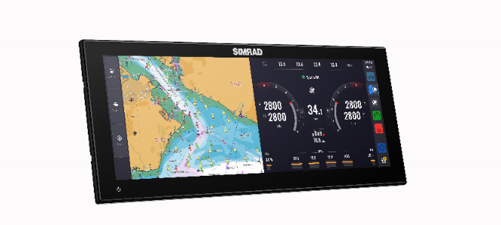

*When compared with a Simrad® NSX 9-inch display

For more information on Simrad Yachting, visit www.simrad-yachting.com.

###

About Simrad Yachting
Simrad Yachting is part of Navico Group, a division of Brunswick Corporation, (NYSE: BC), and features leading marine electronics and navigation products including chartplotters, fishfinders, radars, autopilots and more for both commercial marine and recreational boaters with a history going back 75 years. The Simrad trademark is licensed for use to Navico Group which distributes Simrad products in over 100 countries worldwide. For more, visit www.simrad-yachting.com.

About Navico Group
A division of Brunswick Corporation (NYSE: BC), Navico Group is the world’s leading supplier of integrated systems and products to industries ranging from marine to recreational vehicle and beyond. The Navico Group portfolio is comprised of industry-leading brands in power management, digital control & monitoring, networked devices, and marine electronics. Some of the many brands that make up Navico Group include: Ancor, Attwood, B&G, BEP, Blue Sea Systems, C-Map, CZone, Lenco, Lowrance, Marinco, Mastervolt, MotorGuide, Progressive Industries, ProMariner, RELiON, Simrad, and Whale.

