Smarter, more personal boating — Axopar Connect app
and User Interface bring mobility, safety, and peace of mind
The all-new Axopar Connect app and reimagined Axopar User Interface (UI) on the Simrad multifunctional display screens of Axopar boats mark the beginning of a new era of connected and more personalized boating. Developed with marine electronics leader Navico Group, these innovations enhance both the onboard and offboard experience, bringing boaters closer to their vessels through real-time data, remote access, and intuitive digital tools. Designed to assist the captain in daily tasks, they make navigation, monitoring, and managing the boat's systems more intuitive and efficient.
The Axopar Connect app and new User Interface mark the next step in Axopar’s long-term collaboration with Navico Group. Through this partnership, Axopar has contributed valuable customer insights that, combined with Navico Group’s technological expertise, have led to features and functionalities never seen before in the boating industry. The result is a richer user experience that adds real value for boaters — simplifying daily use, improving safety, and creating a more personal connection between owner and boat.
“Our collaboration with Navico Group shows the power of combining innovation with real-world customer needs. Together we have created something entirely new in boating — an ecosystem that gives our customers confidence, control, and simplicity in every journey,” says Jan-Erik Viitala, Founding Partner at Axopar Boats.
Together with the refreshed Axopar User Interface, the Axopar Connect app forms a complete digital ecosystem for smarter boating. This holistic approach ensures that boaters have the right information at the right time, whether on their mobile device or on the dedicated onboard screen. With Navico Group as a development partner, Axopar will continue to introduce new innovations for both the app and the UI, with the next generation already planned for reveal at BOOT 2026.
Axopar Connect app — boating at your fingertips
Until now, information about a boat’s condition, maintenance, and journey history has often been spread across different systems, making it difficult to access in one place. Axopar Connect changes this. The Axopar Connect app is designed with the user in mind, offering a user-friendly and customizable interface that makes it easy to prioritize the features and information that matter most to you. Designed to give every owner greater control, the new app and onboard UI create a smarter, more personal boating experience that highlights what matters most: the joy of the journey.
Axopar Connect is more than an app — it is a digital bridge between the boat and its owner. It provides live data, remote access to key systems, trip analytics, and personalized tools to enrich every moment on board. Whether preparing for a trip, checking in from afar, or sharing the latest adventure with family and friends, Axopar Connect delivers confidence, clarity, and convenience. It supports safer, more informed boating and provides an unprecedented level of transparency and interaction — both onboard and remotely.
“For boaters, this means greater confidence on and off the water, more control over every journey, and a truly personal connection with their vessel. This is the future of boating — personalized, proactive, and powered by real insight, right at your fingertips,” says Jan-Erik Viitala, Founding Partner at Axopar Boats.

Features that put you in control
To access all core functions of the Axopar Connect mobile app, factory-installed hardware is required — either through the premium Twin Simrad display options or the standalone Axopar Connectivity option package compatible only with Simrad multifunction displays. These packages include the Axopar Connectivity hub, a factory-installed device collecting data from various boat systems and sensors.
This data powers the Axopar Connect app, enabling comprehensive digital boating support and intuitive insights. The Axopar Connectivity hub is available as an option on model year 2026 boats measuring 29 feet and above. Availability and feature sets may vary depending on the boat model and selected options.
For existing Axopar owners, Connectivity can also be added through a retrofit kit, which is limited to monitoring features only and requires Simrad multifunction displays with NMEA2000 compatibility together with Mercury outboards. This retrofit option is feasible on Axopar 45, Axopar 37, Axopar 29, and Axopar 28 models, subject to available space and accessibility to a direct 24h power supply.
Axopar Connect is designed to work around the user’s lifestyle — whether they own a fully connected boat with the Axopar Connectivity installed or simply want digital boating support via their mobile device. At the center of the app is a modular home screen, made up of editable blocks that can be rearranged to prioritize what matters most — from fuel levels and battery status to weather and boat guide. The interface is fast, glance-based, and easy to use.
Axopar Connect transforms raw sensor data into intuitive insights, helping owners monitor the condition, performance, and usage of their boat — whether on board or remotely. The app also includes a dedicated notifications section that compiles alerts, warnings, and system updates in one place. Safety alerts are sent directly to the mobile phone application, notifying the owner of bilge pump activity or if the boat exits its predefined geofencing area, providing peace of mind even when not on board. These are just a few of the many functions available to enhance the boating experience.
Additional real-time monitoring and control functions become available when the boat is equipped with Axopar Connectivity hardware. The following feature breakdown outlines which functions are included by default and which require factory-installed connectivity hardware.
Features available with Axopar Connectivity
To unlock real-time monitoring and control features, your Axopar boat must be equipped with the Axopar Connectivity hardware.
- Customizable home screen, allowing users to prioritize the systems, features, and data that matter the most.
- Trip tracking with route history, speed, distance, and a personal digital logbook to track and revisit past journeys; pin and save points of interest, such as fishing spots or favorite marinas.
- Social sharing, allowing users to share their boating adventures directly from the app.
- Customizable checklists for start-up, safety, packing, or seasonal maintenance.
- Access to maintenance instructions, FAQs, and user guides, ensuring key information is always within reach.
- Access to Boat IQ, a learning hub with model-specific videos and how-to guides.
- Detailed weather forecasts with tide, wave height, and wind conditions for multiple locations; easily check both your home marina and your destination.
- The ability to name your boat for a personalized touch.
- Digital maintenance records can be saved directly in the app, along with dedicated storage for insurance documents, manuals, and other important boat-related information.
- Access to the Axopar Shop, news, and upcoming events.
- Live, remotely accessible monitoring of boat location, engine data, battery levels, fuel, freshwater and wastewater and diesel tanks*, bilge pump activity, and power management*.
- Safety alerts, including geofencing notifications and bilge pump triggers to name a few functions.
- Remote welcome onboard lights control* for a more comfortable approach in dim-lighted conditions, adding both convenience and safety.
* Available features may vary depending on the boat model. Please refer to table nr 1 below. Axopar 45 range is fully connected with all features available. Axopar 29 and 37 do not show waste tank, fresh water, and diesel tank levels. In these boat models the Axopar Connectivity Option does not include control for deck lights or service main switch.

Created with insight – built for the future
The heart of Axopar Connect lies in its technical foundation. The app is powered by the Navico Connect hub, a hardware module integrated into boats equipped with the Axopar Connectivity hub. It connects to onboard systems via NMEA 2000 and communicates through mobile network, Wi-Fi, or Bluetooth, ensuring seamless interaction and data flow between boat and app.
Beyond immediate user benefits, Axopar Connect also enables data-driven product development through anonymized, real-world usage insights. This information helps improve boats, refine services, and guide owners toward smarter, more efficient, and more responsible boating — with updates that support safer navigation and fuel efficiency information.
With a single platform to track boat status, prepare for trips, and share your trips, Axopar Connect becomes more than just a dashboard — it's a proactive companion. Whether onboard or away from the dock, owners can access their boat’s vital information, making Axopar Connect a valuable and reliable tool for everyday boating and long-term ownership.
“Our customers deserve a product that evolves with them. Axopar Connect is our commitment to listen, learn, and deliver a user experience that keeps getting better — because our customers are at the center of everything we do. Looking ahead, we will unlock even greater value with new features and by shaping a user experience that is second to none,” Viitala adds.

Axopar User Interface — simplicity at a glance
The onboard Axopar User Interface (UI) — the touchscreen experience integrated into Simrad multifunction displays on boat models from 29 feet upwards — was first launched in 2020 as a forerunner in the boating industry. It has now been completely reimagined and taken to the next level, introducing a fresh graphic layout and unique features never seen before in boating.
The UI consolidates all vital information and boat systems into one easy-to-read environment. With a single glance, boaters can see everything that matters — from system status, fuel consumption, safety checklists, always a shortcut to multimedia and volume control and navigational data. There is no need to jump around between different systems. This eliminates the need to switch between multiple systems, creating a more intuitive, stress-free experience on the water.
“We have simplified the boating experience in a way that no one else has. You get the full picture of your boat with just one glance — all relevant information, clearly displayed, so you can focus on enjoying your time on the water,” says Jan-Erik Viitala.
Key features of the Axopar User Interface:
The new User Interface offers real-time, interactive guidance, enhancing both performance and safety across different driving conditions. It features two distinct driving modes — Economy and Sport — each designed to support smarter and safer boating. In Economy mode, the interface actively suggests the most fuel-efficient cruising speed, helping the captain optimize consumption and follow best practices for economical driving. In Sport mode, a built-in G-shock sensor monitors boat stress levels and alerts the captain if driving becomes too aggressive. The system provides yellow visual warnings to prompt caution — such as securing loose items — and red alerts to signal that immediate attention is needed to reduce stress on the boat.
- Dedicated checklist page for essential safety equipment and procedures.
- Battery, tank, and engine data at a glance, including engine hours and voltage.
- Two drive views — Economy (for fuel-efficient driving) and Sport (highlighting speed and G-force on selected models).
- Social page that controls the onboard audio system, including source, volume, and playback.
- Trip Intel, showing trip data and fuel efficiency.
The new UI will be available on the Axopar 29, 37, 45, and all BRABUS Shadow models. It is optimized for the latest Simrad NSS4 multifunction displays, ensuring faster response times and improved clarity.
Continuous development — building for the future
Both the Axopar Connect app and the Axopar User Interface are designed as evolving platforms, with regular updates and new features being added over time. The close partnership with Navico Group ensures that innovation continues, combining data-driven insights with customer feedback to make boating smarter, safer, and more sustainable.
The roadmap includes even closer integration between mobile and onboard systems, expanded remote control functions, and smarter service tools — all aimed at making boating easier and creating a truly connected and intelligent boating ecosystem.
Discover Axopar Connect at the Cannes Yachting Festival
Axopar Connect will be showcased at stand POWER 144 in Port Canto during the Cannes Yachting Festival 2025. Visitors can try the app firsthand, on board the latest Axopar models and experience how its smart, connected features enhance the boating experience.
Axopar Connect will be available for download worldwide on the App Store and Google Play by the end of October. To learn more, visit www.axopar.com/connect

*Table 1
Main Connectivity Features: Axopar Connect

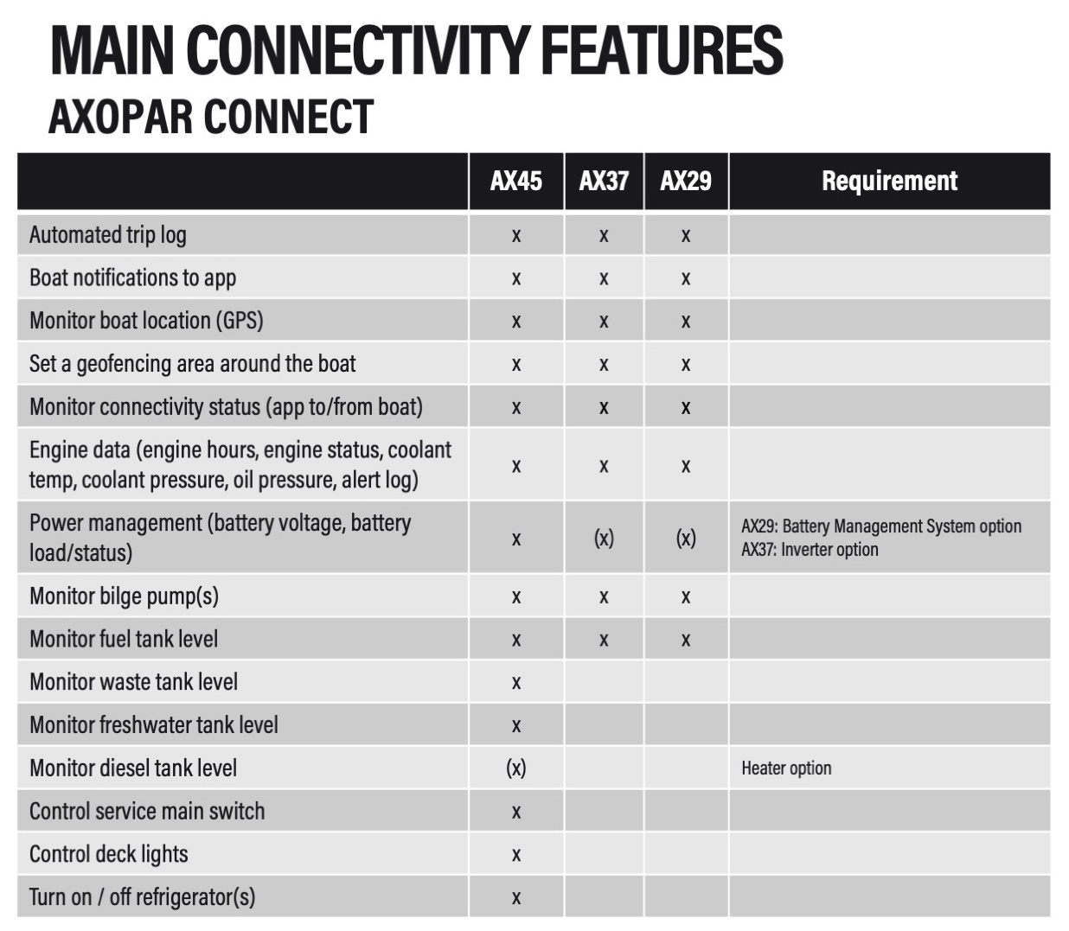

PRICING

Axopar 45 range
- The premium dual display (NSS4 16”) upgrade option, includes Axopar UI: 8.500 €
- The standalone Axopar Connectivity option: 1.350 €
Axopar 37 range
- The premium dual display (NSS evo3 12”) option, includes Axopar UI: 7.990 €
- The premium dual information display (IDS) option: 8.750€
- The standalone Axopar Connectivity option: 1.150 €
Axopar 29 range
- The premium dual display (NSS4 12”) option, includes Axopar UI: 8.800 €
- The standalone Axopar Connectivity option: 1.150 €
OPTION CONTENT
- Factory installed hardware
- 3-year subscription with SIM card (incl. cellular data use)

Link to images and other material for downloading here.
All Axopar releases are available at www.axopar.com/pressroom
About Axopar: Axopar is a Finland-based boat manufacturer and one of the fastest-growing boat brands in the world. Known as "the Adventure Company," it will take you on any adventure, big or small. The company creates multi-functional, accessible, and innovative boats for a global audience. The fleet, ranging from 22 to 45 feet, includes two all-electric AX/E models and is marketed through a strong dealer network in more than 50 countries, with North America as the largest market. Designed in Finland and manufactured in Poland, Axopar has sold 7,500 boats since its founding in 2014. The Group's turnover is over 190 million euros and it employs roughly 1200 people. For more information, visit www.axopar.com

About Navico Group: A division of Brunswick Corporation (NYSE: BC), Navico Group is the world’s leading supplier of integrated systems and products to industries ranging from marine to recreational vehicle and beyond. The Navico Group portfolio is comprised of industry-leading brands in power management, digital control & monitoring, networked devices, and marine electronics. Some of the many brands that make up Navico Group include: Ancor, Attwood, B&G, BEP, Blue Sea Systems, C-Map, CZone, Lenco, Lowrance, Marinco, Mastervolt, Progressive Industries, ProMariner, RELiON, Simrad, and Whale.

For press inquiries or to schedule interviews, please contact:
Anu Vauhkonen
Head of Brand & Marketing
Axopar Boats Oy
Mobile: + 358 40 7652484
Email: anu.vauhkonen@axopar.com

Anna-Lena Nyfors-Norrgård
Marketing Communications Manager
Axopar Boats Oy
Mobile: + 358 50 3010141
Email: anna-lena.nyfors@axopar.com

Adam Fiander or Mike Wills
Broad Reach Communications Ltd
adam@broadreachcomms.co.uk /+44 (0)7703 598903
mike@broadreachcomms.co.uk / +44 (0)7884 075439

