An electrifying sensation from Axopar at Cannes

Helsinki, 6 September 2022

At the Cannes Yachting Festival, 6-11 September 2022, Axopar Boats together with the Norwegian high-performance electric outboard and inboard motors systems Evoy, presents an early-stage prototype that explores the way for functional e-mobility in the future.

The project was initiated as a way for the companies to evolve in tandem with future solutions. The prototype marries the ultra-efficient and versatile Axopar 25 with the eco-friendliness of an electric outboard propulsion.

“Axopar is excited to join forces with innovators that challenge the ‘status-quo’ of the industry. Our partnership with Evoy is a perfect example of two great companies, on a joint mission, to expand the boating community and offer new ways of mobility for the future. We see electrification as a future complement to the industry where Axopar is in the forefront of innovation. We want to be part of evaluating future trends and technologies whatever they might be. At the same time, it is good for everyone to be reminded of today’s limitations and challenges in electrification of boating. This is thus a long-term project that will demand big investments in infrastructure and sustainable cost-efficient solutions for e-mobility to get a strong break through,” says Jan-Erik Viitala, Founding Partner, Axopar.

Axopar sees that there is a demand for smaller boats with a reasonable range that are electrified and can be utilized throughout the world. Especially in regions where Internal Combustion Engines (ICE) are restricted in use, like, for example selected waterways in Amsterdam, Switzerland and France.

Axopar’s first step into the electric boat market offers all the comfort of a renowned Axopar 25, including overnight capabilities, toilet, sink, fridge, sunbeds, shower / storage, weather protection with the T-top roof and canopies. It is the only fully-electric boat that boasts all these features combined into one and is miles ahead of any other electrical boat on the water.

Both the Axopar 22 and 25 were developed with e-mobility in mind and are optimal for electrification due to the models’ efficiency, weight, balance and modular construction.

For the first time together with Evoy, we see within the foreseeable future, the feasibility of offering a credible and uncompromised solution for our boaters, where a range of around 25 nm/charge is achieved at cruising speeds in between 22-30 knots.

The Axopar 25 is one of the rare electric boats on offer that you can take outside of sheltered waters due to its hull design and drivability, being one of the best in its size.

For the most comfortable ride in almost any waters it is crucial to be able to keep a stable speed of around 20-25 knots. Driving in lower speeds in choppy conditions usually results in an uncomfortable and wet ride.

Another feature that sets the Axopar 25 electric prototype apart is its impressive hull efficiency. Axopar hulls have improved with each generation, resulting in higher speed and more extended range with less engine power. Combining this efficiency with an innovative electric engine, showcases Axopar’s dedication towards creating the most comfortable drive even when presented with challenging conditions.

The prototype’s new EVOY engine – the world’s first 300hp outboard electrical engine – proves that high speeds and electrification can go hand in hand. With low consumption, impressive torque, and range, the engine is perfect for boat owners keen to go green and get every inch of speed out of their boats.

The outboard motor runs on an 800 Volts current and is powered by 2 x 63 kWh Kreisel batteries, enabling the prototype to reach a top speed of 50 knots or cover an impressive 25 nautical miles at 25 knots. But that’s not all. The ground-breaking batteries can be charged in about one hour.

The technology available today for the marine industry is developed, initially, for the automotive industry and this is limiting to battery capacity and size. As the automotive industry continues in making break throughs in the efficiency of batteries, this will eventually, over time, be available to the boating industry as well.

Axopar will continue to further develop and refine its models for the future fleet. Once the Axopar e-boats are ready for market launch, approximately 8-12 months from now, they will have been further developed and optimized for electric propulsion. This is in order to provide the best experience and efficiency, once the technology is thoroughly tested and proven.

“Until now, our boats’ unique features such as easy handling, multifunctionality and competitive prices have attracted experienced and new owners alike. The prototype for an electric day cruiser will interest and attract a new kind of customer and bring more people out on the water,” says Jan-Erik Viitala.

For now, Axopar’s prototype represents a great leap forward for the company and the boating industry. The prototype is our testament to adaptability, resourcefulness, and passion for innovation. Axopar is committed to its ongoing effort to innovate and to electrify the boat segment in collaboration with industry leaders like EVOY.

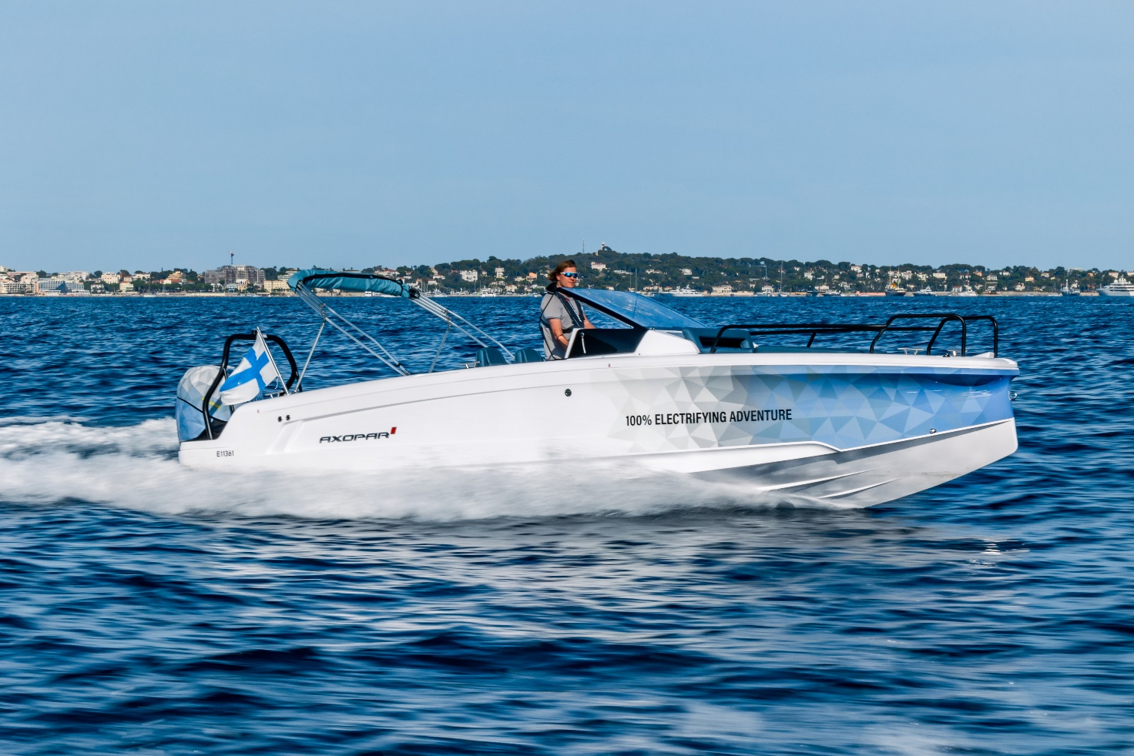
Image caption: The prototype marries the ultra-efficient and versatile Axopar 25 with the eco-friendliness of an electric outboard propulsion.

All Axopar releases are available at https://www.axopar.com/press

Media contact for more information on this release:
Ms Marit Holmlund-Sund
Head of Brand & Marketing
Axopar Boats Oy
Mobile: +358 (0)40 538 3519
Email: marit.holmlund-sund@axopar.com

Press Information:
Adam Fiander or Mike Wills
Broad Reach Communications Ltd
adam@broadreachcomms.co.uk /+44 (0)7703 598903
mike@broadreachcomms.co.uk / +44 (0)7884 075439

Axopar in brief:
Axopar, the adventure company, is one of the fastest-growing boat brands in the world. The success derives from the "one boat, one world" concept. It stands for boats that are multi-functional and accessible for the many, anywhere around the world.
As a forerunner committed to continuous innovation, the company listens to its global community of axoparians and shares the same respect and passion for nature. Axopar's mission is to open new perspectives by bringing people out on the water and creating boats that make waves in the boating industry.
www.axopar.com

