BRABUS Shadow 900 Stealth Green Signature Edition: BRABUS Marine’s latest newcomer in the Shadow 900 range

Confident. Authentic. Uncompromising. The BRABUS Shadow 900 Stealth Green Signature Edition has what it takes to conquer the great outdoors and wild seas in a most modern fashion.

Düsseldorf, 21.01.23 — BRABUS Marine continues to redefine luxury day boating with its latest design evolution, the BRABUS Shadow 900 Stealth Green Signature Edition. The high-performance luxury adventure tender will be unveiled to the world on the 21st of January at Boot 2023 in Düsseldorf, Germany.

A striking embodiment of uncompromising marine high-performance and modern outdoor lifestyle, this unmistakable Signature Edition is the newest addition to the BRABUS Shadow 900 range. With its charismatic looks and high-class functionality, it’s a perfect fit for those who are ready to push the boundaries – BRABUS style and make an undeniable statement of design, one of a kind luxury and individuality.

At first glance, the boat impresses with an evocative BRABUS 1-Second-Wow design scheme, combining a distinctive paintjob in BRABUS “Stealth Green” with matching Signature Style graphics, a wide range of high-grade carbon elements, contrasting matte black detail work, Masterpiece and Sign of Excellence badges as well as the BRABUS “Sunrise” upholstery color. The confident contrasts in color and material exudes a highly luxurious, contemporary outdoor aesthetic – in this combination a most unique design transfer that guarantees owners will stand out from a crowd, anywhere.

Continuing the legacy of the award-winning BRABUS Shadow 900 range, the Stealth Green Signature Edition is defined by BRABUS typical attention to detail – ranging from its paint scheme – a result of passionate, labor-intensive fairing, painting and polishing processes – to BRABUS’ high-quality, quilted upholstery material and branded detailing found all around the boat. More than just an eye-catching detail, however, the boat’s Sign of Excellence is a veritable seal of craftmanship. It guarantees that every unit is built to the highest possible standards with the best materials, underscored by cutting-edge technology and engineering. For the first time, the dash panel, fender boxes, the optional LED roof light and the extended carbon fibre package come in an exclusive matte black carbon, perfect for those preferring a contemporary and competitive look.

The unveiling of the Stealth Green Signature Edition is synchronized with the launch of the Panerai Submersible S BRABUS Verde Militare Edition. A brand new, highly-exclusive dive watch and the latest product of the collaboration between expert Italian watchmaker Panerai and BRABUS. The Panerai Submersible S BRABUS Verde Militare Edition features a host of the same hallmark style cues introduced by its predecessors. However, the use of new materials and a completely reimagined signature flair place it well within in a league of its own – conceptualized to perfectly match the day boat in its design and functionality.

Built for blistering acceleration, the Stealth Green Signature Edition is powered by dual Mercury Marine 450R 4.6-liter V8 Four Stroke racing engines, producing a combined output of 900 hp. This means, the day boat can reach 60+ knots like it’s a walk in the park. Aside from its exhilarating speeds, the edition features another key element inspired by the BRABUS portfolio of Masterpiece supercars: The helm area. Everything on the boat’s clean and ergonomic dashboard is within reach. But that’s not all. Fingertip controls, backlit switches, touchscreen technology as well as the multifunctional steering wheel make this one of the most futuristic consoles.

Furthermore, the dashboard features a full HD Simrad dual touch ‘Glass Helm Information Display' for maximum on-screen detail and unprecedented levels of built-in functionality. An updated BRABUS User-Interface, including a digital version of the Panerai timepiece, G-shock monitoring, navigation controls, engine management, on board entertainment and driving-assist features allows Shadow 900 drivers to take total control of their on-water experiences. Owners that opt for the Extended Navigation package can benefit from an even larger array of functions, including two additional 9” screens, on-board connectivity and 4G mobile WiFi router, VHF unit with AIS receiver, a Halo20+ radar, 5" touch display with digital light switching for the front lounge and a BRABUS lock box.

Optional features do even more to create an unrivalled experience for owners seeking adventurous recreation and luxury high-performance. The multi-storage package, for example, is ideal for water sports enthusiasts seeking a boat to accommodate all their adventure gear. The aft option, including a spacious aft cabin with a queen-size bunk in addition to the front lounge, is ideal for those looking for even more space during a laidback night’s sleep and luxurious comfort. Owners that love entertainment can opt for an integrated infotainment unit that comprises a 42-inch flat-screen 4K TV and Apple TV connectivity.

From a G-Shock sensor to a 1st Mate Marine Safety & Security System, the luxury day boat is fitted with impressive features to ensure afficionados and novices alike can explore the world’s waters worry-free. The G-Shock sensor helps drivers navigate rough weather in safety while the 1st Mate System, delivers important safety alerts, and offers features like man overboard monitoring, distress messaging, and a theft deterrent.

The BRABUS Shadow 900 Stealth Green Signature Edition is being revealed to a global fan base of discerning luxury boating enthusiasts with a showcase of the BRABUS Shadow 900 Sun-Top model at stand B-59 (hall 4) during Boot Düsseldorf, 21-29 January 2023. The Sun-Top model is representing the full Signature Edition which furthermore consists of an open Spyder model and a fully enclosed XC Cross-Cabin.

NEW! BRABUS SHADOW 900 STEALTH GREEN SIGNATURE EDITION RANGE HIGHLIGHTS
- Spyder (S), Sun-Top (ST), XC Cross Cabin (XC) models
- Exclusive Stealth Green Signature Edition yacht paint in BRABUS Stealth Green with high labor-intensive fairing, painting and polishing process
- Stealth Green Signature Style graphics running across the front of the hull
- Exclusive BRABUS carbon in matte black finish
- Updated fender box panels in BRABUS carbon with matte black finish
- Dashboard panels in matte black carbon
- Carbon fibre LED roof light bar matte black carbon (optional)
- BRABUS sports seats with full carbon backrests, exclusively in matte black finish (only with extended carbon fibre package option)
- Highly exclusive Stealth Green BRABUS Masterpiece badges
- Exclusive Stealth Green Sign of Excellence badges

Standard Equipment Highlights
- BRABUS quilted upholstery color options: BRABUS Sunrise, BRABUS Graphite, BRABUS Red, BRABUS Sapphire, BRABUS Cappuccino, BRABUS Platinum
- Main Cabin with BRABUS Fine Leather black/light grey or BRABUS Fine Leather light grey upholstery options (XC)
- Bow option Sun Lounge: extended sunbathing area on the gullwing doors with additional cup holders and storage.
- Bow option Sofa with table (no sunbathing area on the gullwing doors)
- Gullwing doors
- Front lounge in exclusive BRABUS fine leather in cool grey/black color scheme with red accents
- Queen size bed mattress in grey/black square pattern with red accent
- Dual installation Mercury Racing 450R Verado XL engines
- Mercury joystick piloting helm control system with skyhook digital anchor and autopilot functions
- Glass bridge/information display with two 12” screens
- Panerai watch integrated into the Simrad user interface
- Intelligent steering module with integrated controls
- 1st mate marine safety & security System
- Wireless phone charger
- Wall pockets in BRABUS design
- Sleek hull badges in black chrome
- Hi-Fi audio entertainment system
- Bow thruster side -power SE60
- Fixed bow anchor windlass with remote control
- Shore-power 230V or 120V incl.isolator, 60Ah charger
- Electric opening/closing of sliding sun-roof awning (ST, XC)
- Integrated electric toilet under foldable L-sofa
- Fresh water system 80l including cabinet with sink in front lounge
- BRABUS composite decking in platinum/black
- Shower on aft deck, port side
- Water ski pole in matt black paint
- Side rails
- BRABUS Shadow 900 badging and logotypes
- BRABUS ‘Sign of Excellence’ insignia
- BRABUS double B designations and detailing
- LED bulwark step lights
- LED search light
- Complete set of harbor covers in red
- Antifouling in black

BRABUS SHADOW 900 - Extended Optional Package Highlights
- Aft bench (XC)
- Wet bar package
- Gas cooktop on wet bar
- Multi storage compartment
- Aft-Cabin accommodation package: Fine Leather in cool grey/black color scheme with red accents
- Folding aft deck seats*
- Extended carbon fibre package in matte black finish
- Carbon fibre LED roof light bar in matte black finish
- Extended navigation package: extended glass bridge/ information display with two additional 9” screens, on-board connectivity and 4G/USB mobile wifi router, VHF unit with AIS receiver and Simrad Halo20+ radar (XC/ST), 5” touch display in front lounge, BRABUS Lock Box including PIN control via touch display
- Enclosed toilet compartment
- Warm water option**
- Air-conditioning in front lounge
- Air-condition in main cabin (XC)
- Zero emission power bank
- Heater Webasto
- Infotainment media wall
- Roof racks
- Fishing targa
* Not available with BRABUS Aft-Cabin or Multi Storage compartment
**Warm water option not available with air-condition in both front lounge and main cabin

Specifications:
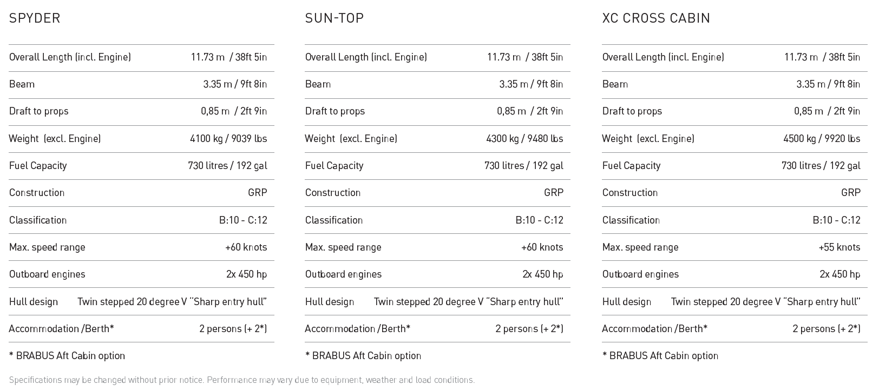

FACT SHEET

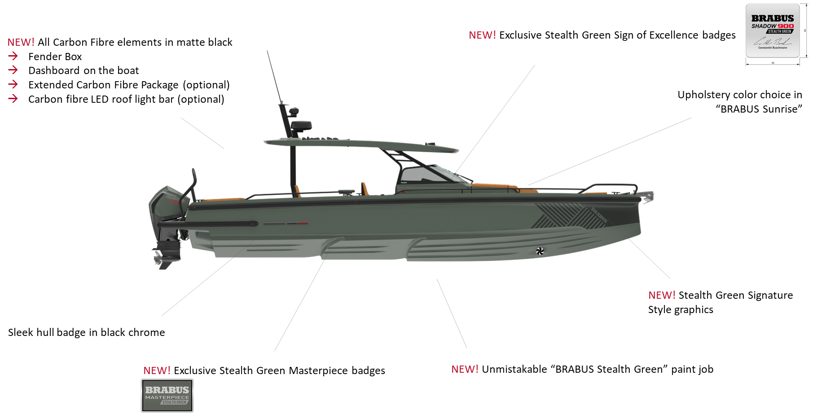

Media contacts for more information on this release:

Ms Marit Holmlund-Sund
Head of Brand & Marketing
Axopar Boats Oy
Mobile: +358 (0)40 538 3519
Email: marit.holmlund-sund@axopar.com

Press Information:
Adam Fiander or Mike Wills
Broad Reach Communications Ltd
adam@broadreachcomms.co.uk / +44 (0)7703 598903
mike@broadreachcomms.co.uk / +44 (0)7884 075439

About BRABUS Marine
BRABUS Marine is the cutting-edge alliance between two of the most renowned companies in their respective genres. Bringing together the award-winning Finnish boat builder Axopar Boats and BRABUS, a world-renowned luxury mobility brand out of the heart of Germany’s Ruhr-Region, to redefine luxury day boating through ultra-exclusive and exciting powerboats. BRABUS Marine specializes in luxury products for global markets and is driven to become one of the world’s most iconic boat brands.
www.brabusmarine.com

